Walk 33 The Lower Olchon Valley
Last walked in April 2018

Description. An 8 km (4.9 miles) strenuous walk up and down a mountain, crossing field after field after field, luckily they are not ploughed. Beautiful scenic views as you make your way up. There is a bucket load of stiles to cross.
Start. Longtown Parish Hall. Explorer Map OL13 Grid 324287.
Direction from Tesco’s roundabout (Turn milometer to zero). Take the A465 to Abergavenny. At 9.7 miles you TR for Longtown 6. At 10.5 miles TL for Longtown 5. At 15.1 miles you TL for Longtown. At 15.3 miles TR at the ‘The Crown Inn’, (Established in 1751), and head for Longtown Village. A little further on, passed the pub on your L and at a T Junction, you TR for Longtown Castle. Two tenths of a mile along the road you park by Longtown Parish Hall, which is on the L. [15.5 miles]

1. Parish Hall. Out of the car park onto the road and TR. Walk for 120m and TL to cross over a slate slab (by a telephone box), and walk along an enclosed Public Footpath, then cross over a stile into a field F1. Go half R and cross over a stile into F2. Bear slightly L across this field to go over a stile in the L hand corner onto a road and TL. Cross a road bridge and TR and walk along the road to Ewyas Harold. Further on, (about 100m) you cross Escley Brook and TL over a stile into a field F3. Head off half R to cross the field corner and to go up some wooden steps and thru a small wooden gate onto a farm track/drive where you TL. After about 80m the drive turns into a muddy track that you continue along, (farm buildings are on your L), to reach 2 metal gates. Go thru the gate on the R side and into a field F4. Continue in the same direction, keeping to the hedge/tree line, and Escley Brook, on your L. In the field corner you cross over 3 planks of wood and a stile into F5. Continue along the field edge to cross over a slate stile into a wooded area. Cross 3 planks of wood and a little further on you walk up wooden steps and over a stile into F6. Go straight across this field and thru a wooden gate into F7. Follow the L field edge to the corner where you cross a stile/wooden gate into F8. Bear R down this narrow field to TR thru a wooden gate into a wooded area (Permissive Access – Natural England). Continue along the L inside edge of the wood. Cross a stile/wooden gate into F9, and follow the fence on your L, (look behind you. The scenery is of the Black Mountains in the distance, with Hay Bluff on the R hand side). Go thru wooden gate gap into F10. Go thru a wooden gate and across F11, bearing slightly L. Go thu a small wooden gate and a few paces further on you go thru another small wooden gate and into F12 and head for the L hand corner. Go thru a small wooden gate, across a wooden footbridge and along the R edge of a small wooded area, to cross a stile/wooden gate into F13 and TL. A short distance further on you go across another stile/wooden gate and onto a road and TR.

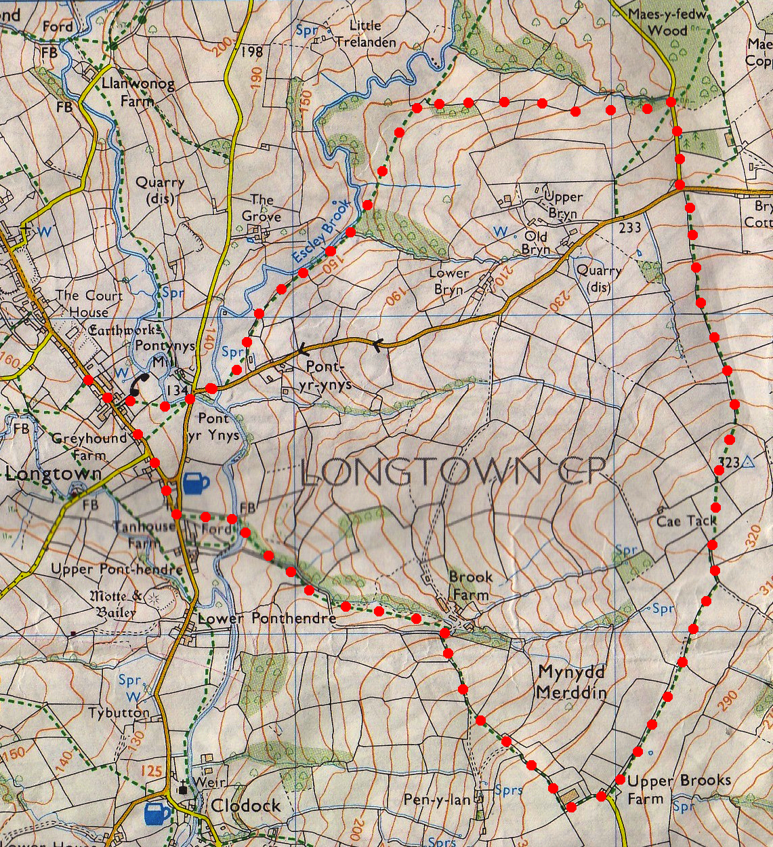
2. Road. Walk along a narrow road and at the T-junction you TL. 20m along the road you TR to cross stile/metal gate into a field F1, and head up to the top, keeping to the R field edges as you go. Cross a wooden footbridge into F2. Cross over two stiles into F3. Cross two stiles into F4. Go thu 2 metal gates into F5. Cut straight across F5, heading for the far corner. There are 2 gates, go thru the gate on the L and straight on across this field F6, to reach the far corner. Go straight forward, thru 2 metal gates and along an enclosed farm track, after a short distance the track ends and you cross a stile/metal gate into F7 where you TR. Keep to the R field edge and when you reach the corner you cross a stile. Go thru a narrow strip of wood to cross two more stiles into F8, keep to the fence on your R. Just past Upper Brooks Farm that is on your R, you TR across a stile onto a tarmac drive and TR.
2

3. Upper Brooks Farm. Walk along the drive as it goes past the farms on either side. Follow drive/enclosed track thru metal gate, farm buildings on your R. The enclosed track bends R and goes down hill. The track descends steeply, and when the track bends L, by a cattle grid, you go straight on thru a metal gate into F9, keep to the R field edge. At the bottom of the field you bear R, go thru a metal gate and continue down an enclosed farm track. Go thru a double metal gate onto track junction and TL. Bear R to go thru a gate into F10 (ignore the gate on the L side). Head diagonally R down this field to follow the gully/brook that’s on your R hand side. Go thru a metal gate and down an enclosed track (the gully/stream is on your R). Go thru another metal gate; bear R across a small field to follow the gully/stream down to the river, going thru a metal gate and a short distance along a farm track. At a T-junction you TR, a little further up you TL to cross the river via a concrete footbridge and go into F11. Go straight across this field to cross a stile/gate onto a road junction. Cross over two roads and TR, head for Longtown Castle. Walk up this road back to the car park.
1
3

